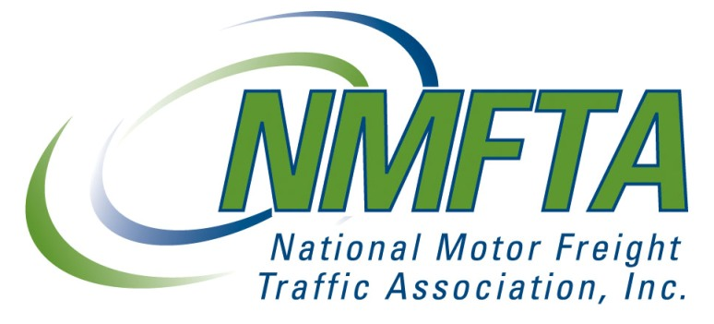

ADLR COMPANY
39 IRON HILL ROAD #15
NEW BRITAIN, PA 18901
CERTIFICATE OF STANDARD CARRIER ALPHA CODE (SCAC) RENEWAL
The Standard Carrier Alpha Code of
ADLR COMPANY 39 IRON HILL ROAD #15 NEW BRITAIN, PA 18901
MC-851168 US DOT-2467097
ADRF has been approved for:
This Alpha Code will apply only to the company name shown above from June 30, 2014. Should the company name or address change, please notify the National Motor Freight Association, Inc. at the address below.
Alpha Codes ending with the letter "U" have been reserved for the identification of freight containers. If your Alpha Code ends with the letter "U", it should be used only for this purpose. A non-U ending Alpha Code should be obtained to satisfy other requirements such as company identification for Customs, Electronic Data Interchange, freight payments, etc.
If you participate in the Bureau of Customs and Border Protection (BCBP) automated programs (ACE, AMS,CAFES, FAST, PAPS), your SCAC and related company information has been sent to BCBP electronically and is updated on a nightly basis. If you have encountered a problem using your SCAC with BCBP, or a copy this letter has been requested by BCBP, only then should you forward the requested information (email preferred as a PDF or TIF attachment) to the following address:
CBP SCAC Processing Bureau of Customs and Border Protection 7681 Boston Blvd., Beauregard 1st Fl Wing A Springfield, VA 22153 AMS.SCAC@DHS.GOV
NOTICE: Renewal of the above listed SCAC is unrelated to participation in the National Motor Freight Classification (NMFC). inconnection with freight rates. For participation and membership information, please call (703) 838-1810

1001 North Fairfax Street • Suite 600 • Alexandria, VA 22314-1798 • ph: 703.838.1810 • fax: 703.683.1094 web: www.nmfta.org • email: scac@nmfta.org

